Ideation Phase Empathize & Discover

|  |  |
| --- | --- |
| Date | 1st April 2025 |
| Team ID | SWTID1743512046 |
| Project Name | Tune Trail |
| Maximum Marks | 4 Marks |

# Empathy Map Canvas:

An empathy map is a strategic, visual tool designed to capture key insights into the behaviors, thoughts, and emotions of users. For Tune Trail, it plays a vital role in aligning the team’s efforts with the real needs and motivations of both music listeners and independent artists.

By focusing on the user’s goals, pain points, and decision-making processes, the empathy map provides a deep understanding of their experience. This allows the team to craft features and design interactions that address genuine user challenges, driving engagement and optimizing platform satisfaction.

# Empathy Map: Listener

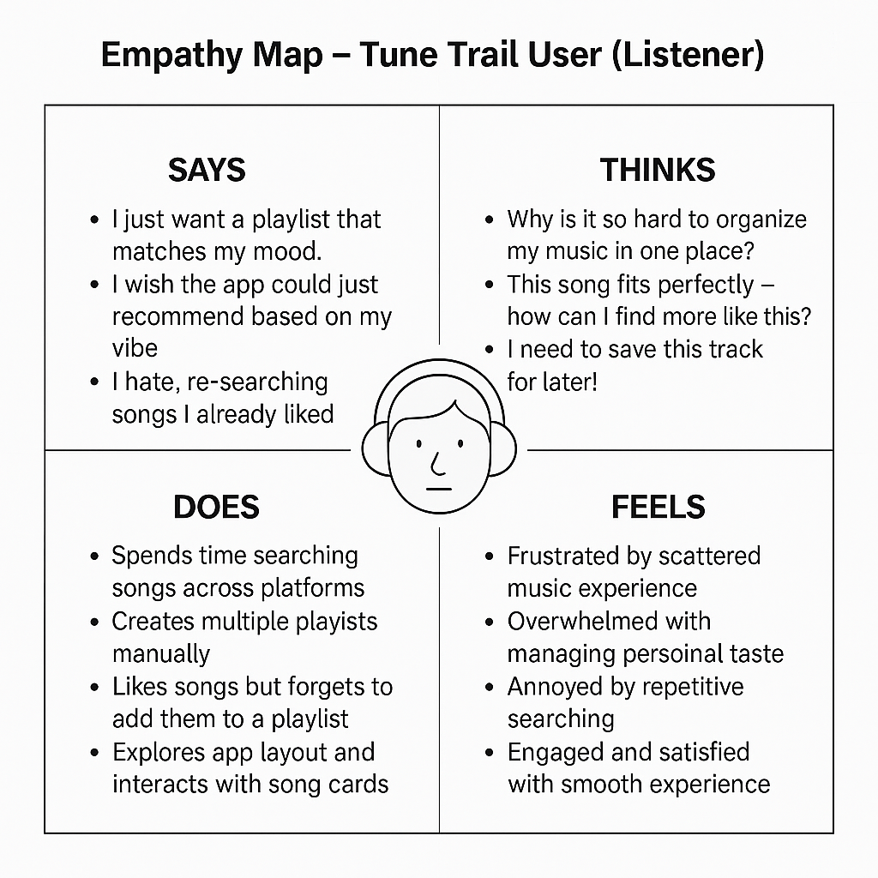

**Empathy Map: Artist persona**

